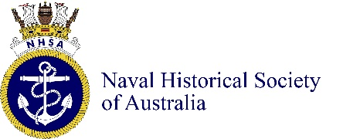

THE WRITING OF AUSTRALIAN NAVAL BIOGRAPHIES

Zoom Presentation: Wednesday 16th February 1100 2022

Overview
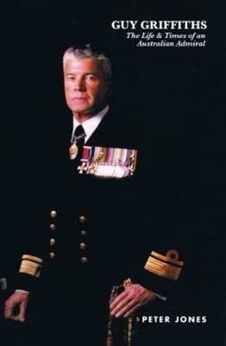
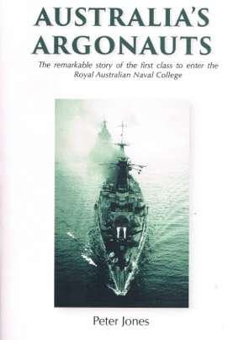
Although Australia has a rich naval history there are less than a dozen biographies written about the Australian naval figures. This presentation will discuss the great value of biographies in improving our understanding of our naval past. It will also outline some of the presenter’s experiences and practical aspects in writing biographies in Australia.

Presenter – Vice Admiral Peter Jones AO DSC RAN retired
Peter Jones served in the RAN for 40 years and in that time commanded the frigate HMAS Melbourne and later the multinational Maritime Interception Force during the Iraq War. Since his retirement he has been an Adjunct Professor with the Naval Studies Group at the University of NSW (Canberra) where he produces the Australian Naval History podcast series. He is also the President of the Australian Naval Institute. His two biographies are Australia’s Argonauts: The remarkable story of the first class to enter the Royal Australian Navy College (2016) and Guy Griffiths: The Life & Times of an Australian Admiral. He is now writing the biography of Vice Admiral Sir Albert Poland.

Details
Date and Time: 1100, Wednesday 16th February 2022 (Sydney time)
Click the link below to join the ZOOM meeting.

Join the Zoom Meeting by clicking on the link below

Please join us

